CAS PY 106

In-class note 5

1. Work & Energy
2. 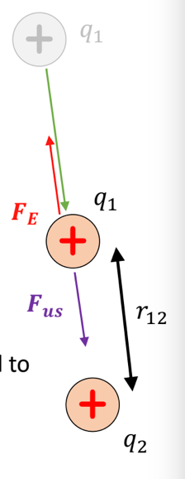
3. In the figure above, imagine q1 is very far away and want to move to a position r away from q2
4. Need to apply force against electrostatic repulsion (which increases as we move the charge closer to q1)
5. In order to accomplish this, need to apply positive work W=fd\*cos(theta) where theta here is 180 degrees
6. Positive work implies that this system of two charges has positive energy
7. 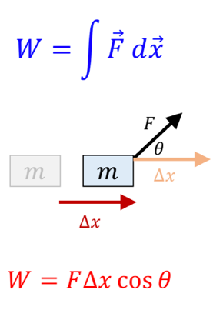
8. Electrostatic potential energy of two charges
9. Charges move because it had electrostatic potential energy where

U = k\*q1\*q2/r

1. It is scalar and is positive when q1 and q2 have same charges (repel)
2. It is negative when q1 and q2 have opposite charges (attract)
3. Electrostatic potential energy of three charges
4. Adding one additional charge q3 will cause change in energy
5. 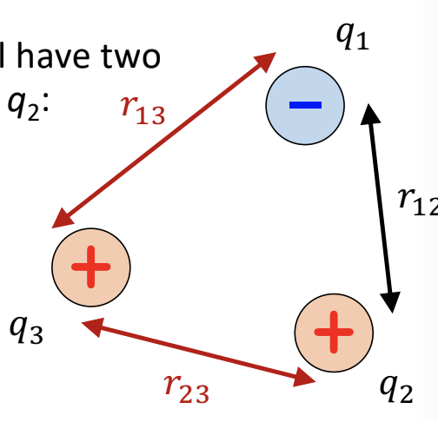
6. U = k\*q1\*q2/r1 + k\*q2\*q3/r2 + k\*q1\*q3/r3